Note for building Retail Manager

**Table of Contents**

1 Introduction 1

2 GitHub account 2

2.1 Created new repository below 2

2.2 Clone the repository 3

2.3 Main branch vs. Master branch 3

2.4 Git Pull 4

2.5 Git status 4

3 Connect GitHub with Visual Studio 4

3.1 Comment changes 10

3.2 Git pull then git push (or Sync in Visual Studio) 11

3.3 Suggested to do a git fetch before git pull 12

3.3.1 Difference between git fetch and git pull 12

4 Creating Empty Solution Using Visual Studio 13

4.1 Open Visual Studio -> Create new project -> Blank Solution 13

4.2 Give the solution and folder as the folder of the repository 14

4.3 The solution is created 14

5 Create ASP.NET Web Application (.NET Framework) Project 15

6 Run the app and see the API help page 22

7 Register a user with Sample User information 23

8 Get access token 24

8.1 Question? 25

9 Get values of the user 25

9.1 Need to get the token see Section 8 25

9.2 Get values of the user by using the token 25

10 Location of user data stored 26

11 Add userId obtained from the get request https://localhost:44375/api/values 27

11.1 Add “using Microsoft.AspNet.Identity;” 27

11.2 Get and assign userId in the get function 28

11.3 Return the userId 28

11.4 Tested the end point with Postman returning the userId below 29

12 Difference between API controller and MVC controller 29

# Introduction

Learning ASP.Net from:

TimCo Retail Manager Course

https://www.youtube.com/watch?v=TDuG1WU3GvM&list=PLLWMQd6PeGY0bEMxObA6dtYXuJOGfxSPx&index=2

# GitHub account

## Created new repository below

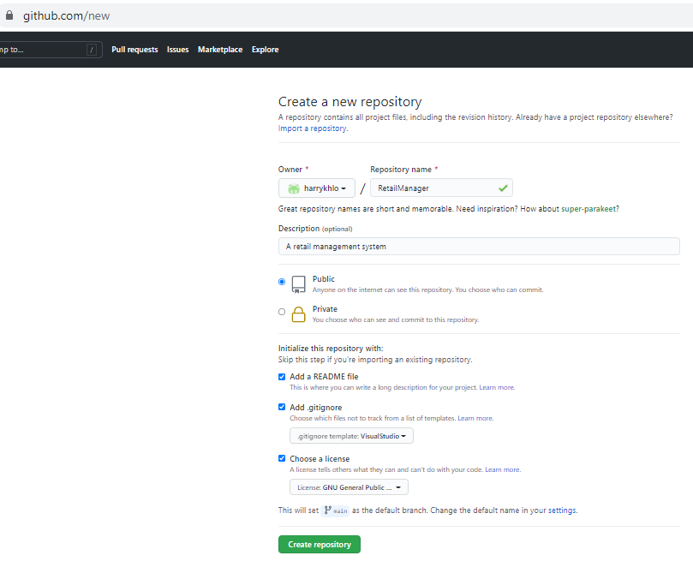

## Clone the repository

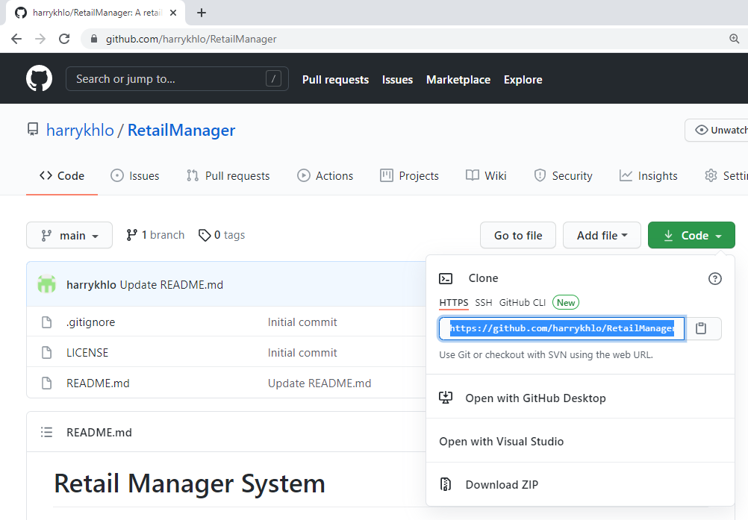

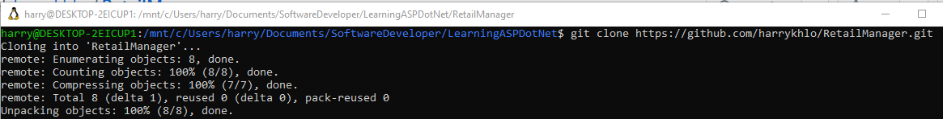

## Main branch vs. Master branch

refer: <https://stackoverflow.com/questions/64249491/difference-between-main-branch-and-master-branch-in-github>

GitHub is working on replacing the term "master" on its service with a neutral term like "main" to avoid any unnecessary references to slavery,

You can read here for more background the reason for the change here: <https://www.zdnet.com/article/github-to-replace-master-with-alternative-term-to-avoid-slavery-references/>.

About renaming your branch from master to main, there are a lot of guidelines. For example: <https://jarv.is/notes/github-rename-master/>.

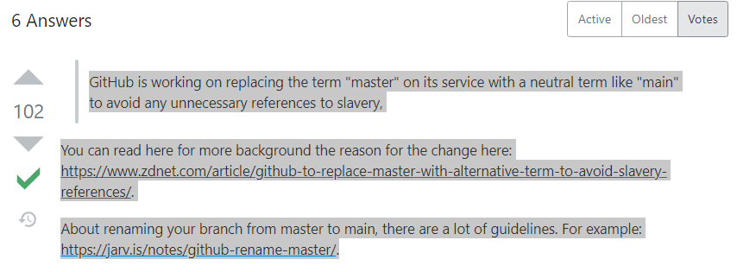

## Git Pull

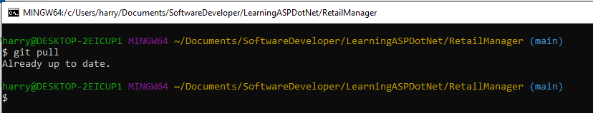

## Git status

Git status after create a new blank solution

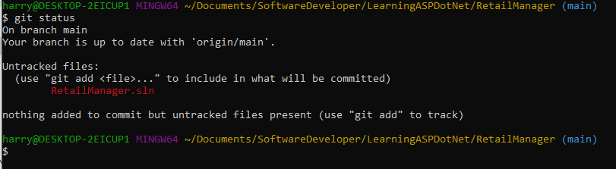

# Connect GitHub with Visual Studio

From Visual Studio

-> Manage Extensions -> GitHub Extension for Visual Studio ->

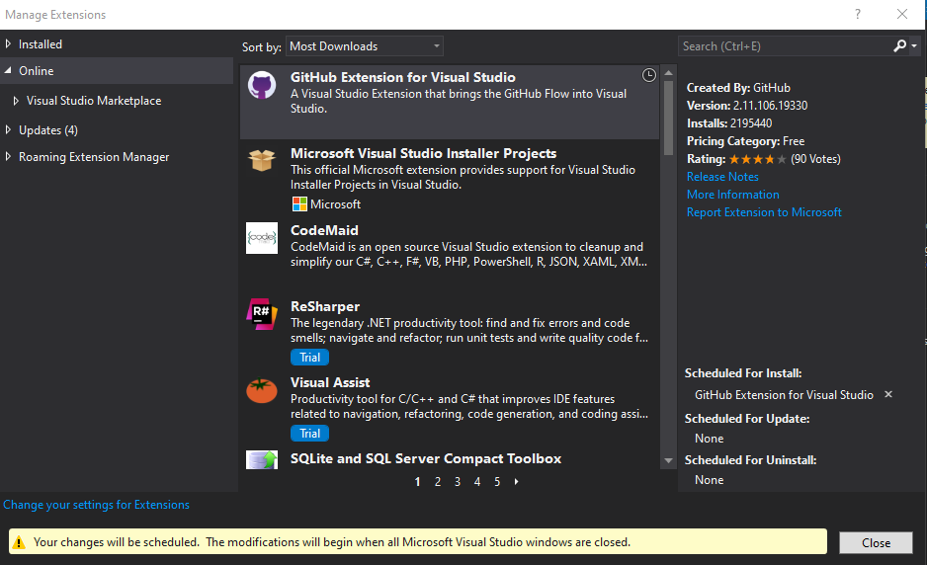

Close Visual Studio -> the extension will be installer automatically

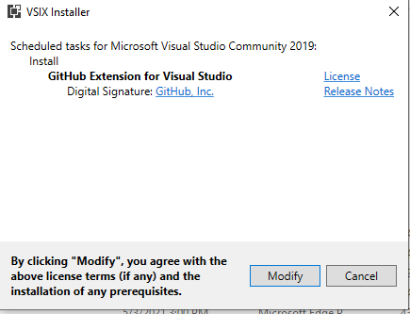

Open the visual studio again -> Team Explorer -> GitHub -> Connect…



Sign in GitHub

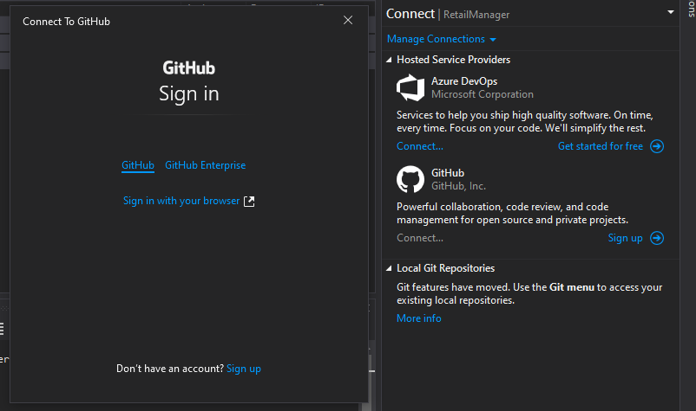

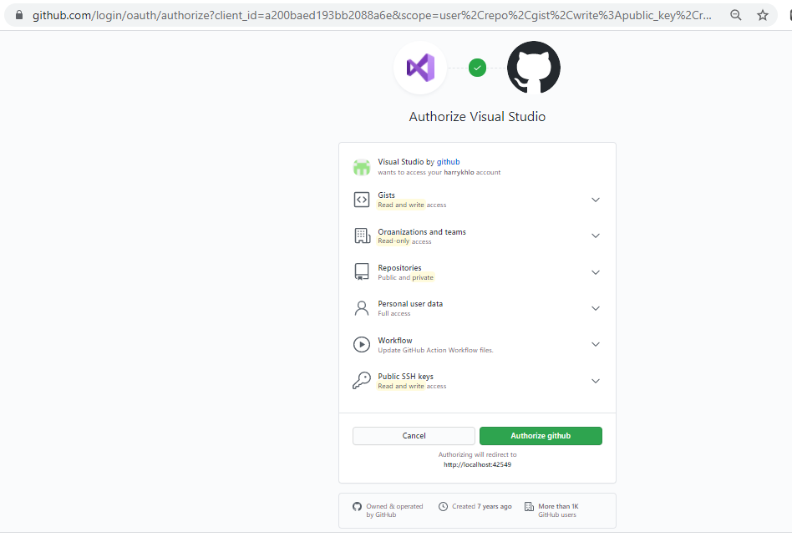

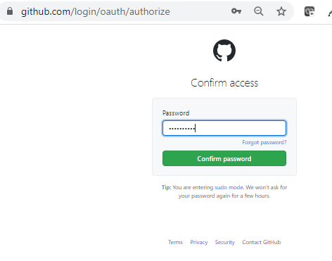

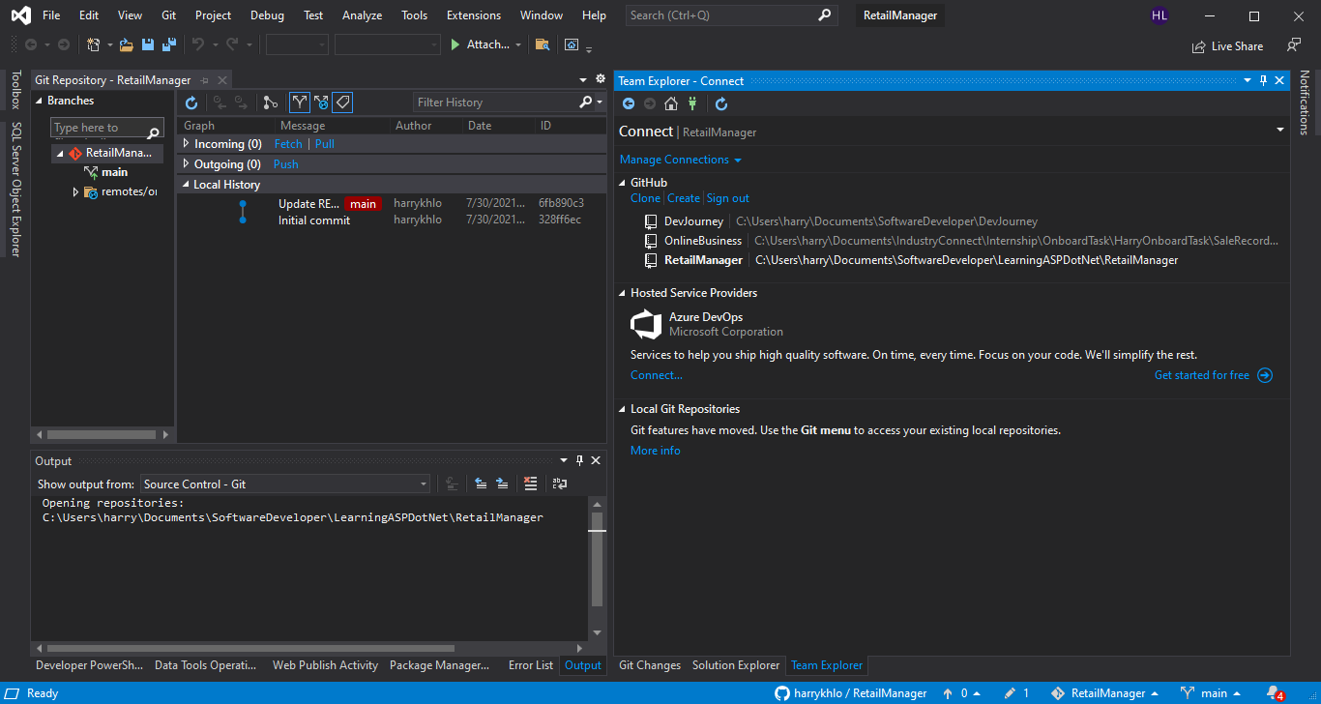

Select correct repository by double clicks

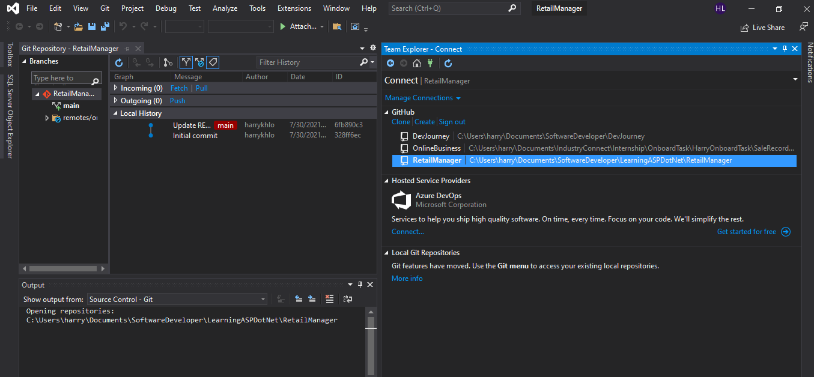

Select Git change

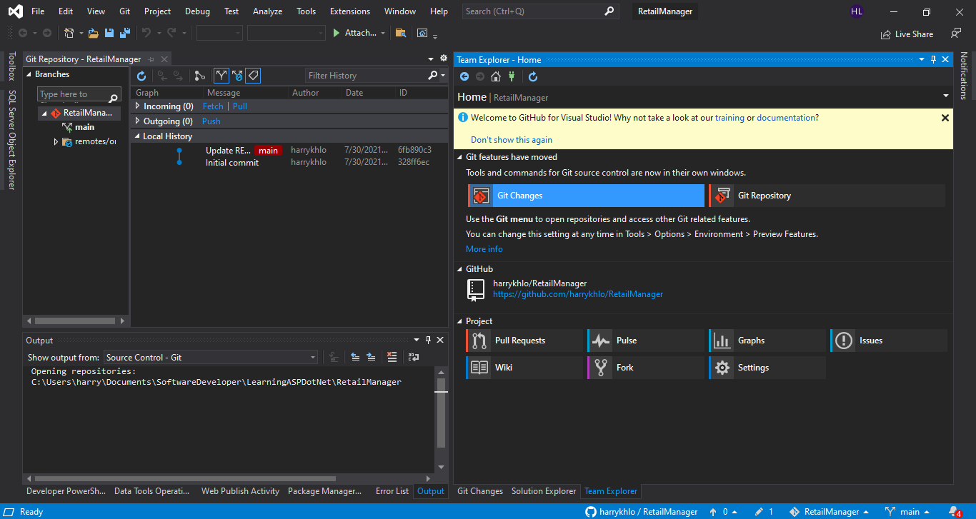

Right click the changed file and select “Stage”

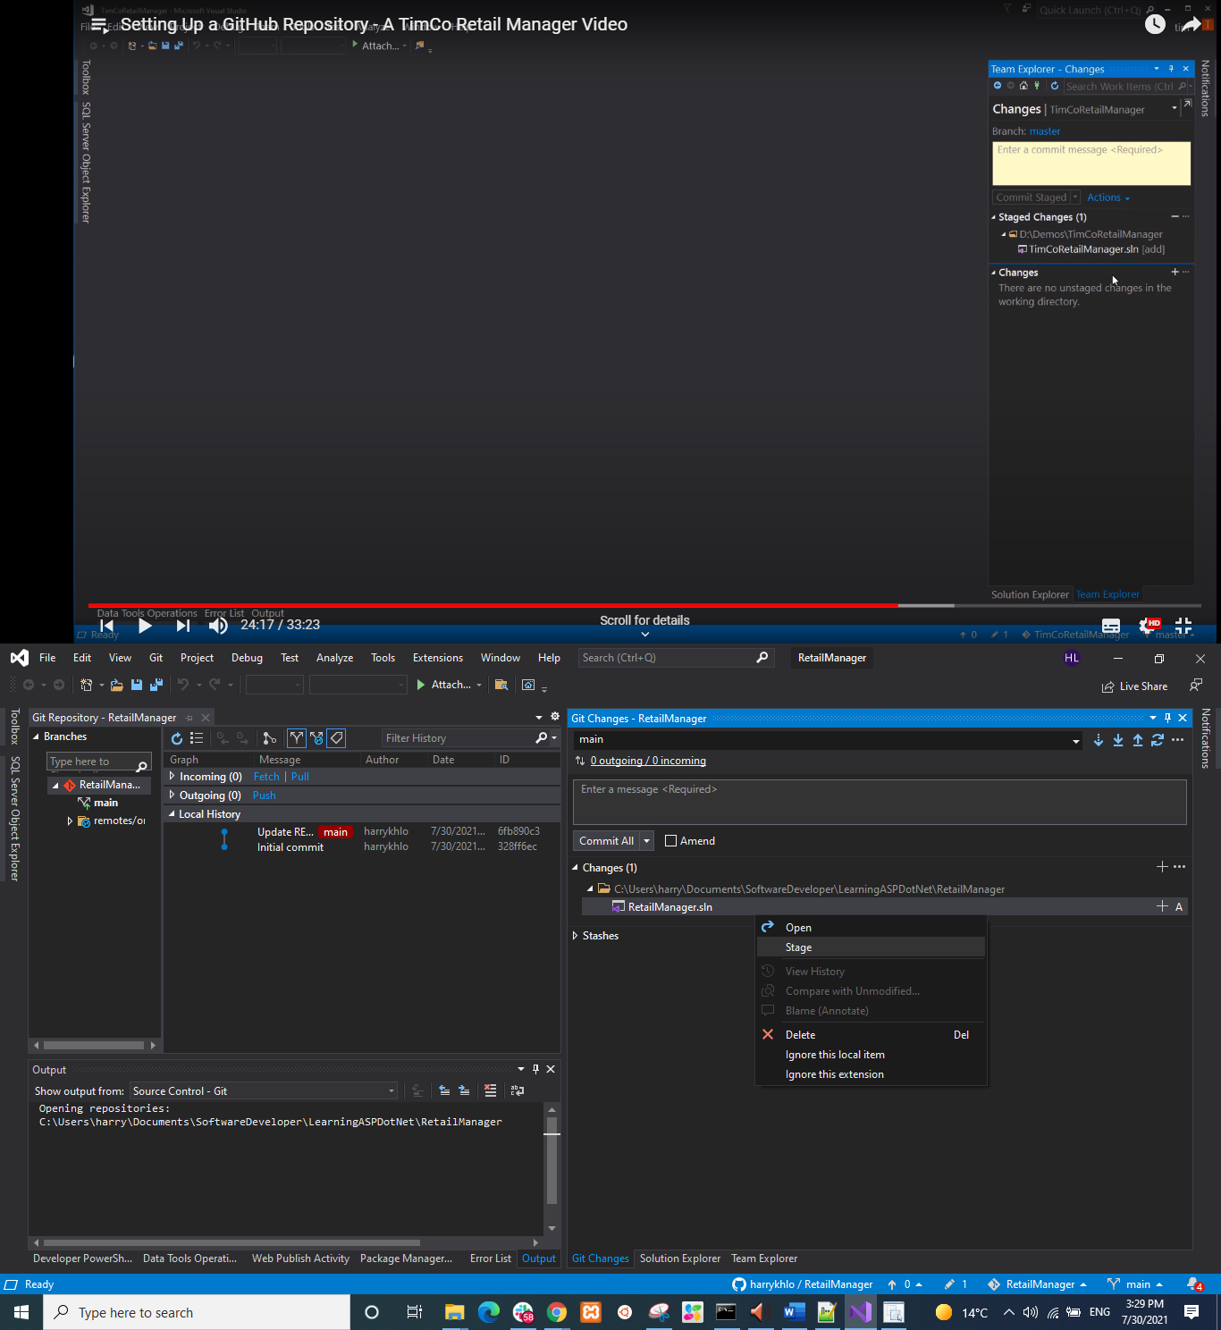

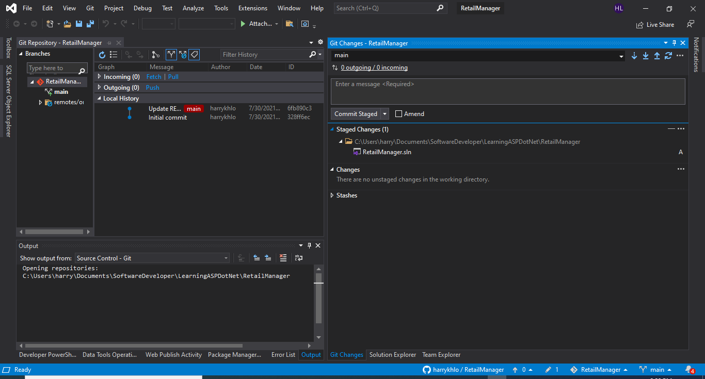

## Comment changes

Add comment message

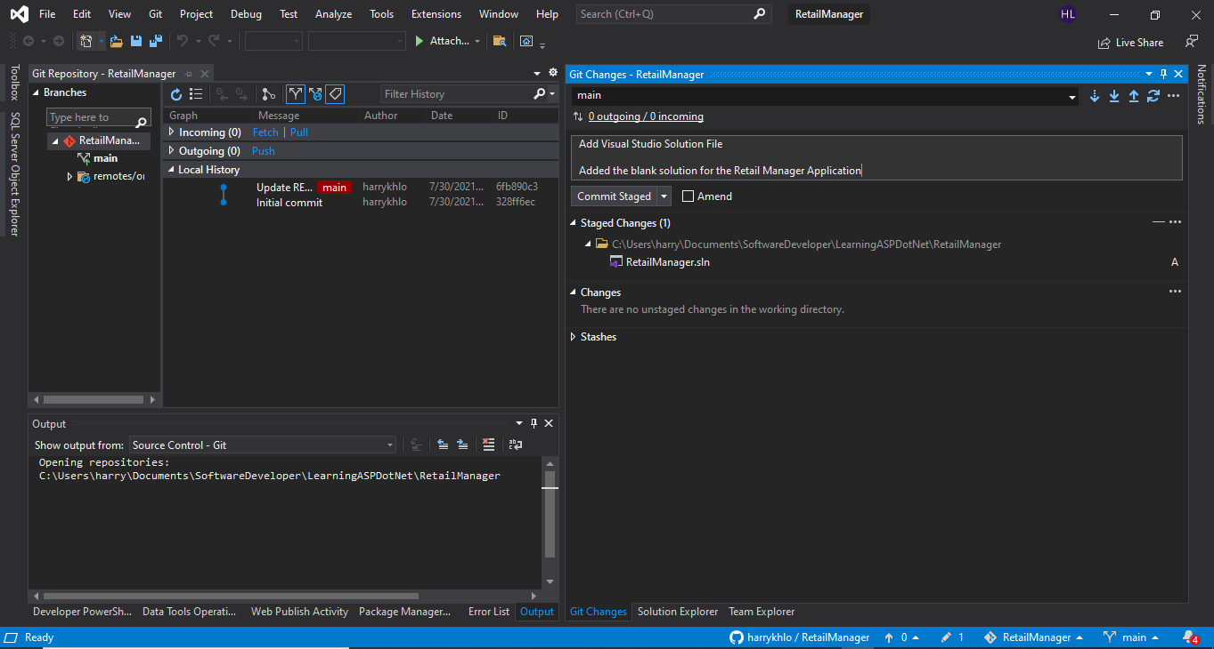

Click “commit staged” above and will show below that the change is committed locally

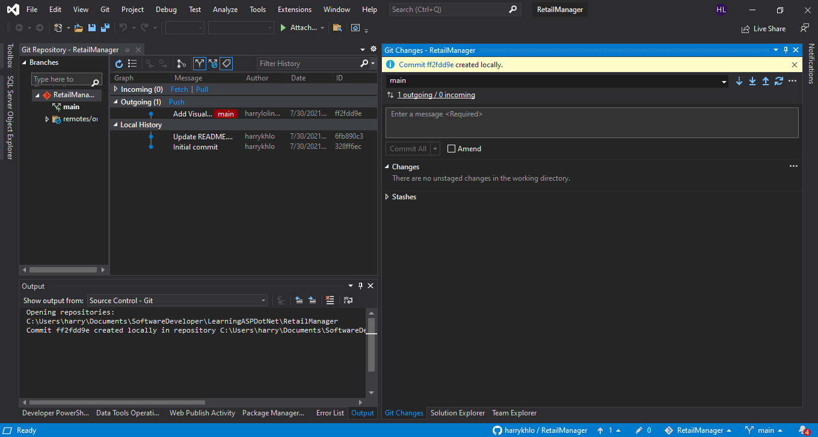

Git status in command line will show below

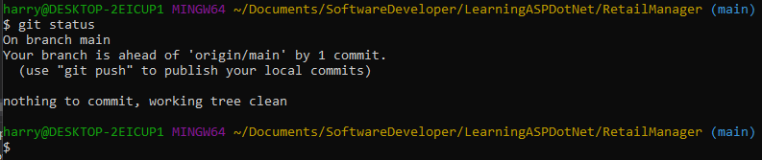

## Git pull then git push (or Sync in Visual Studio)

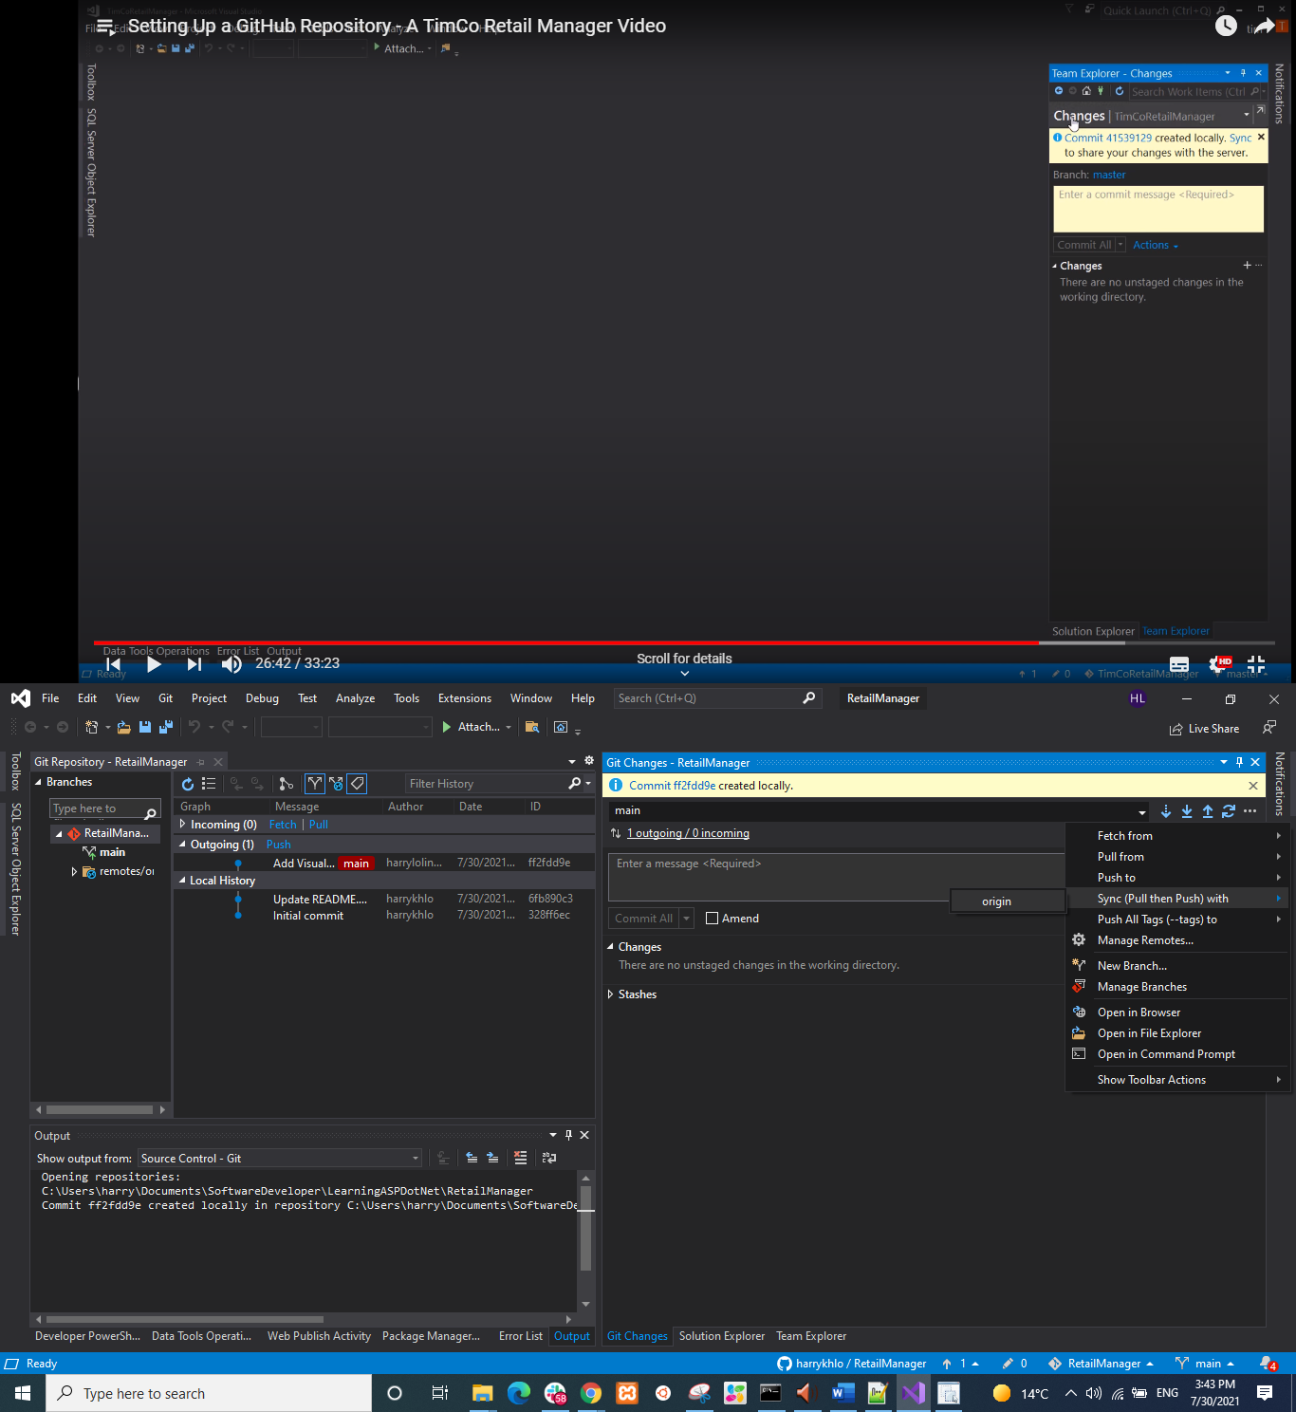

After sync

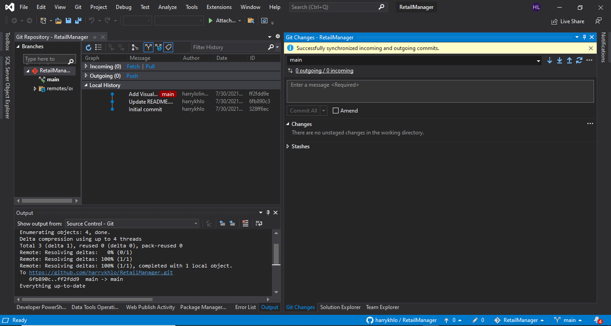

## Suggested to do a git fetch before git pull

### Difference between git fetch and git pull

<https://www.freecodecamp.org/news/git-fetch-vs-pull/>

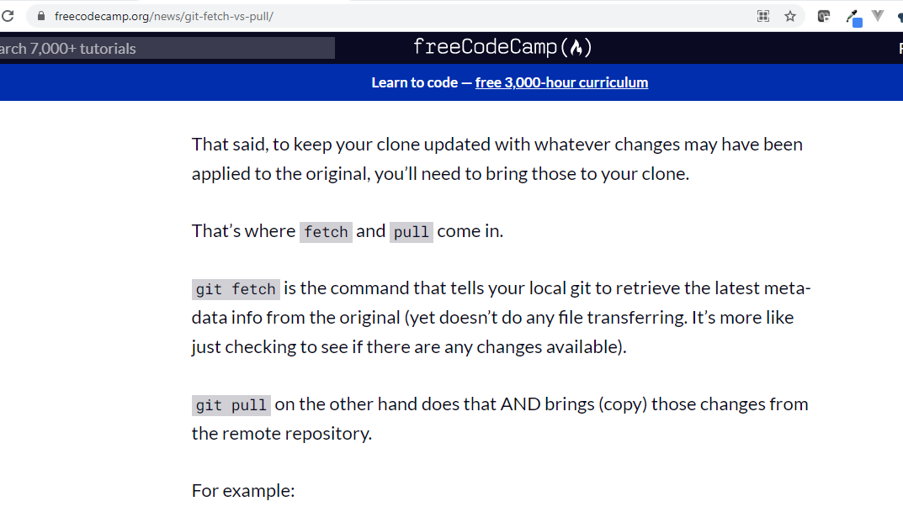

# Creating Empty Solution Using Visual Studio

## Open Visual Studio -> Create new project -> Blank Solution

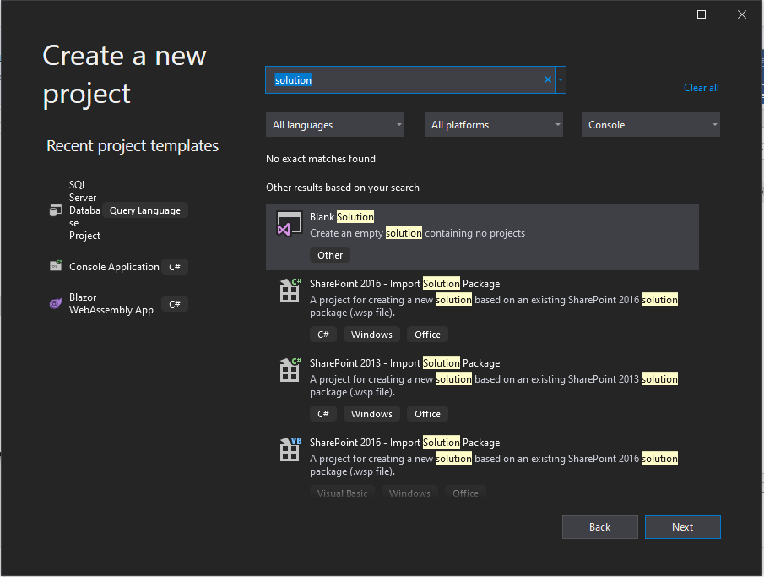

## Give the solution and folder as the folder of the repository

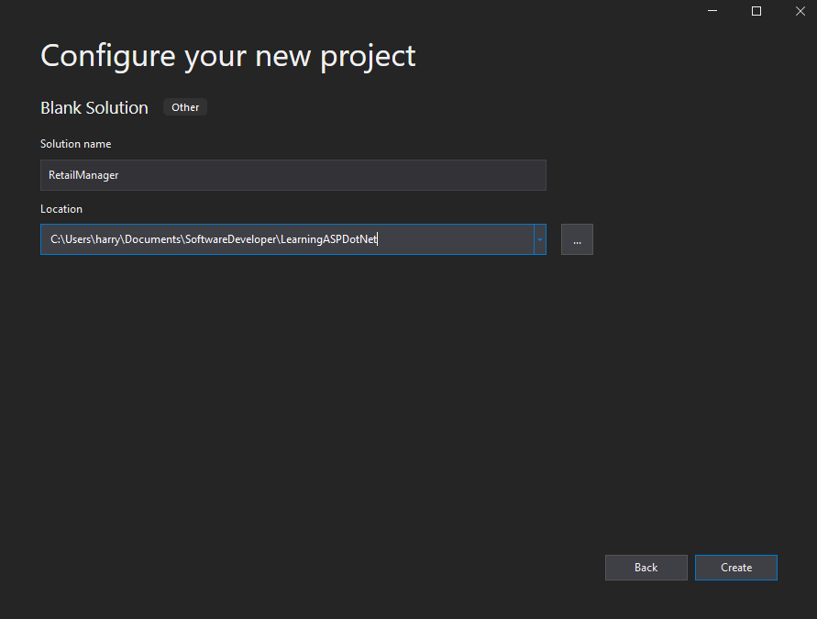

## The solution is created

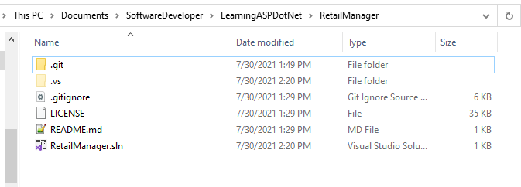

# Create ASP.NET Web Application (.NET Framework) Project

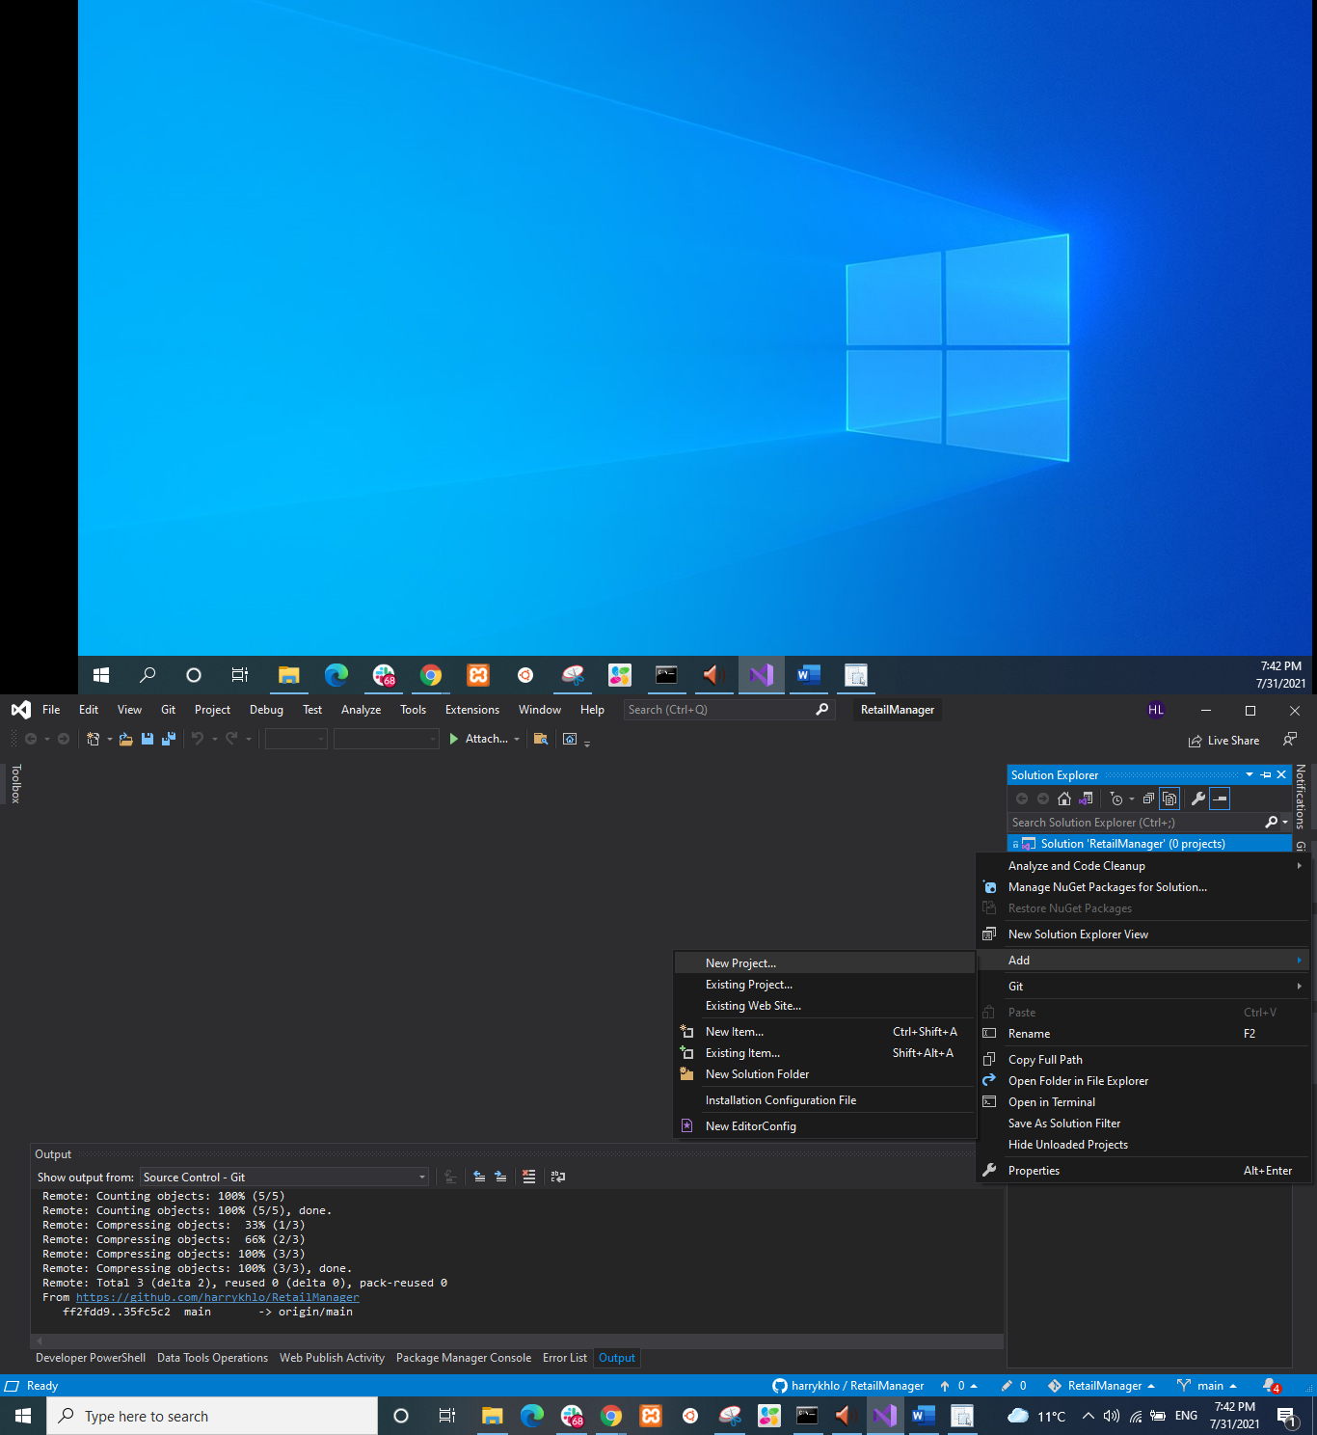

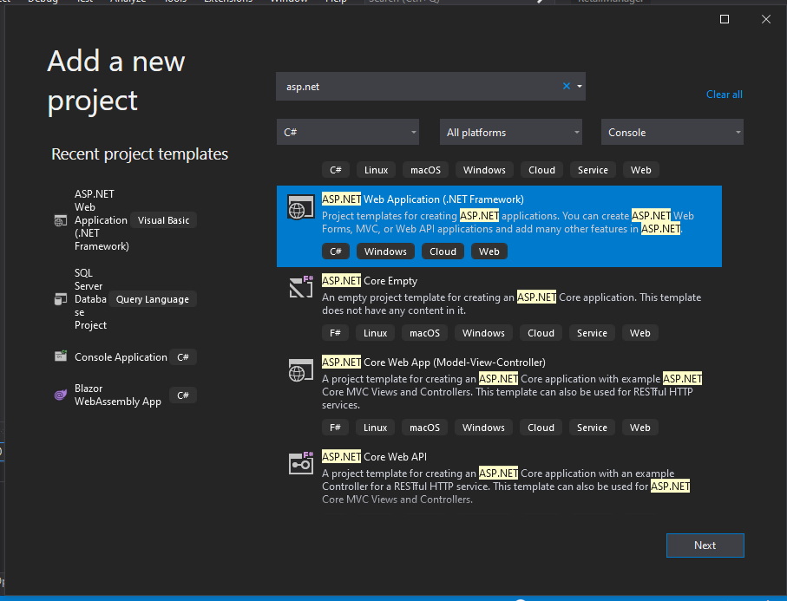

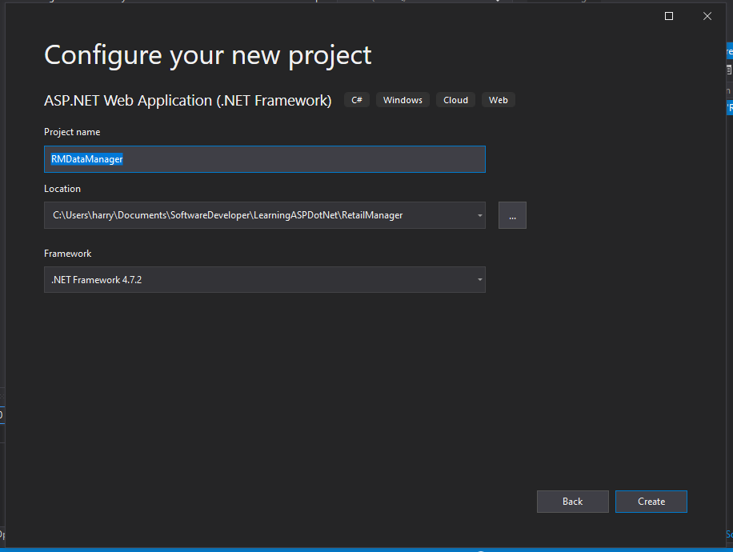

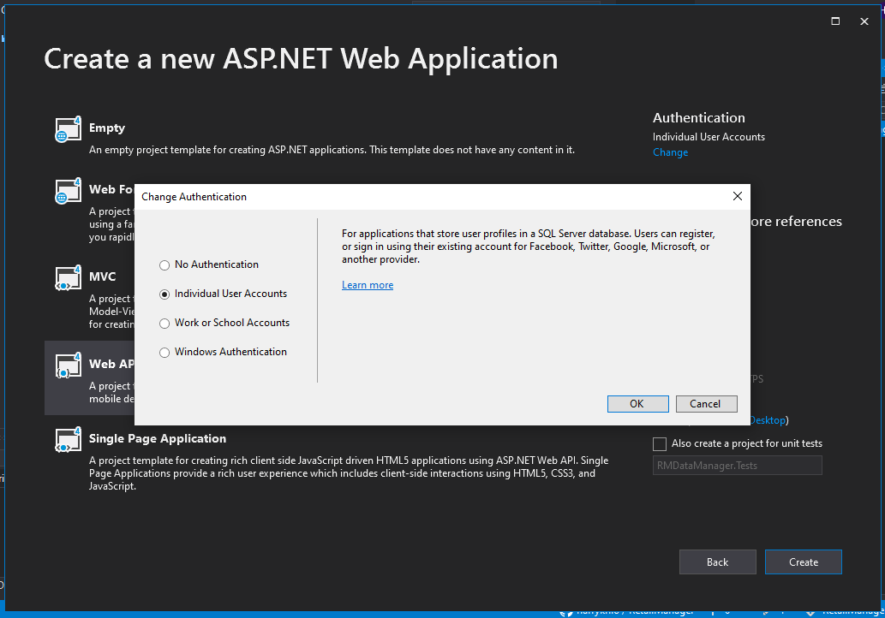

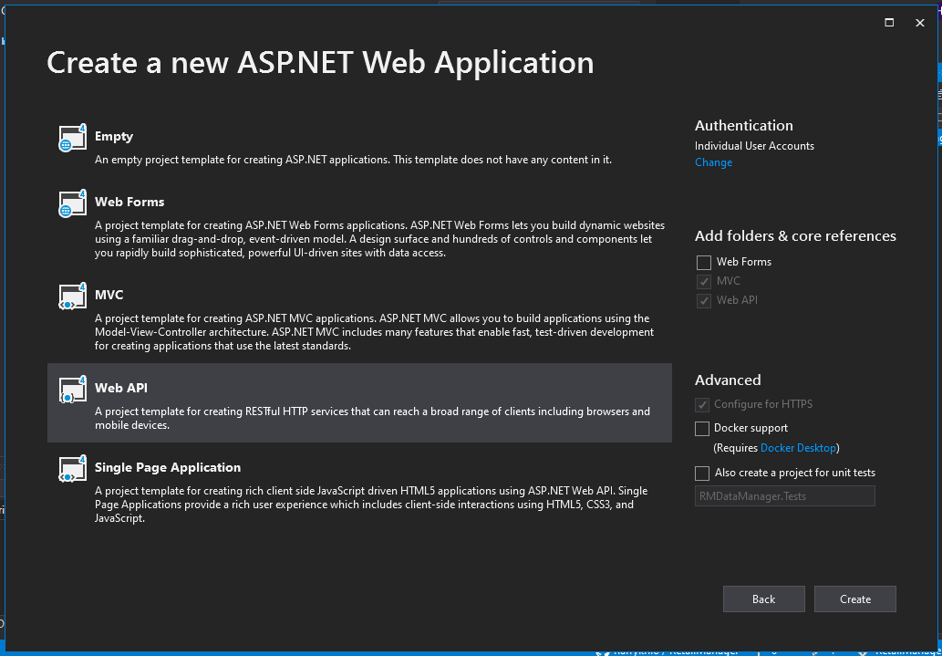

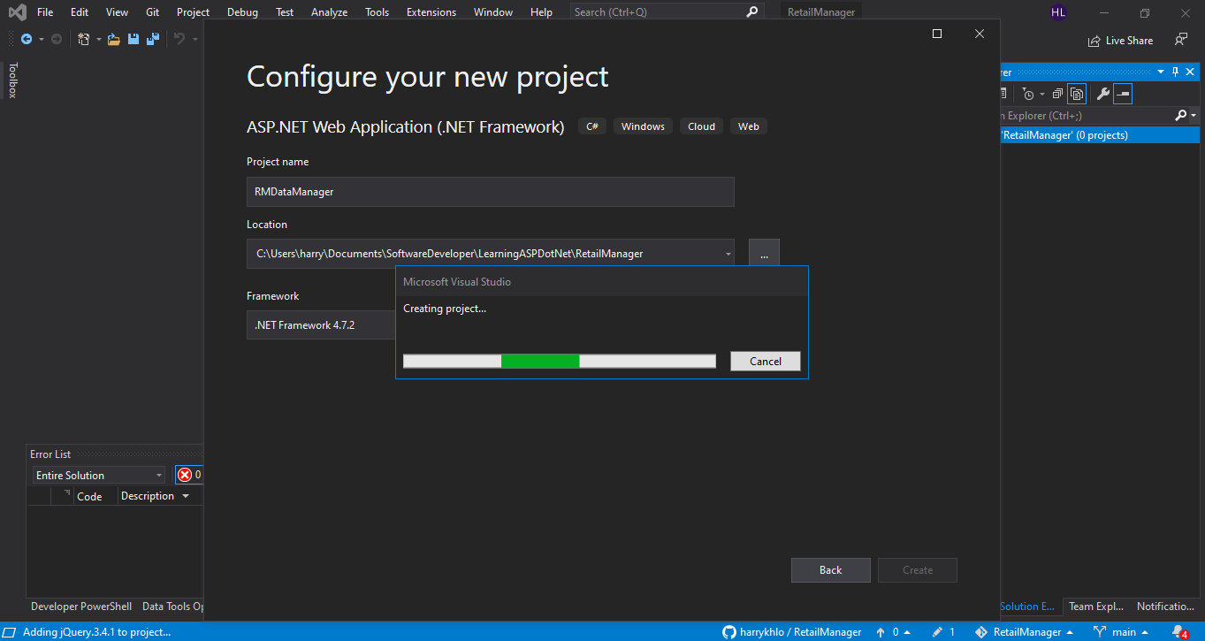

Project is created below

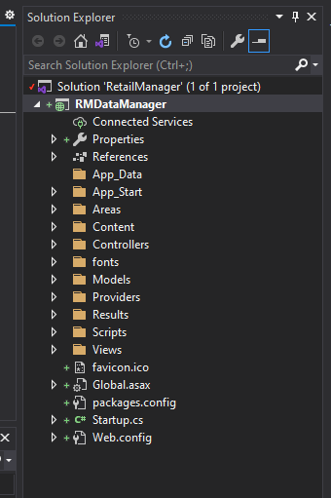

Updated NuGet except bootstrap

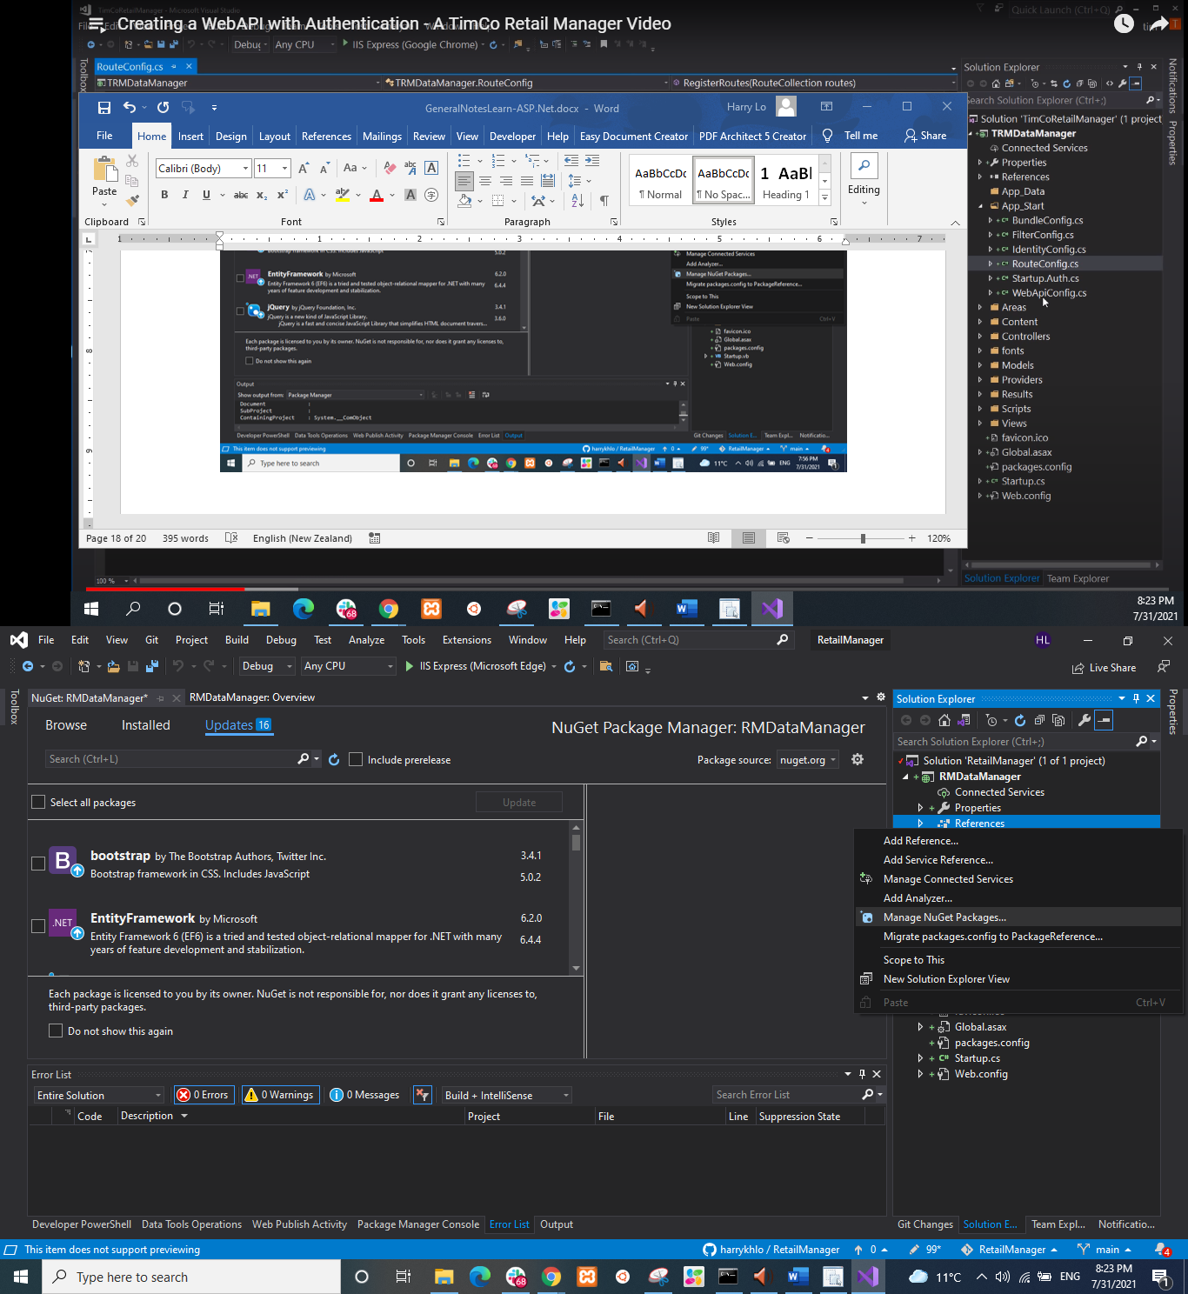

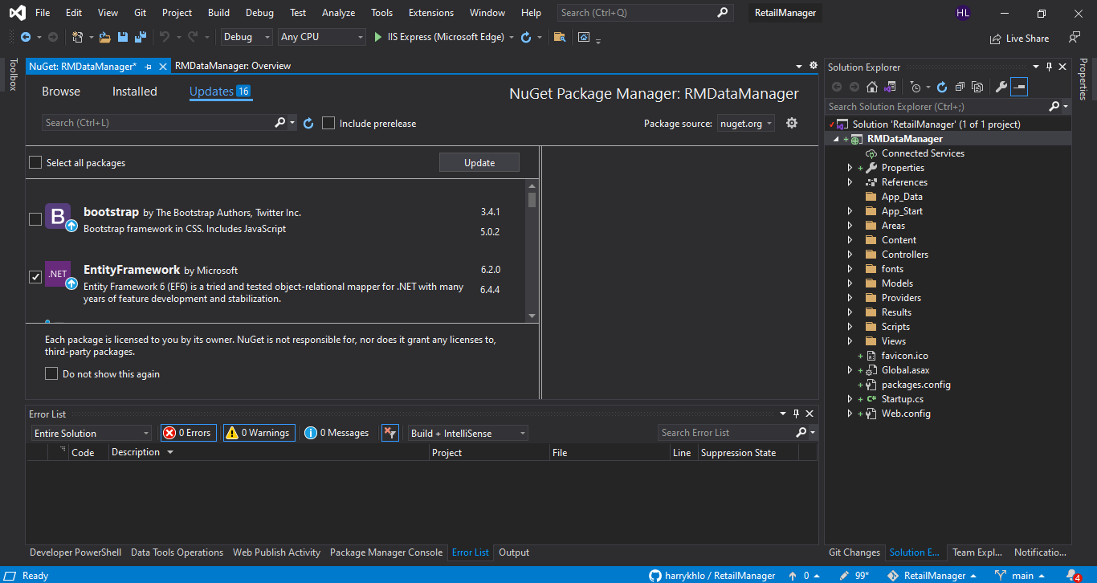

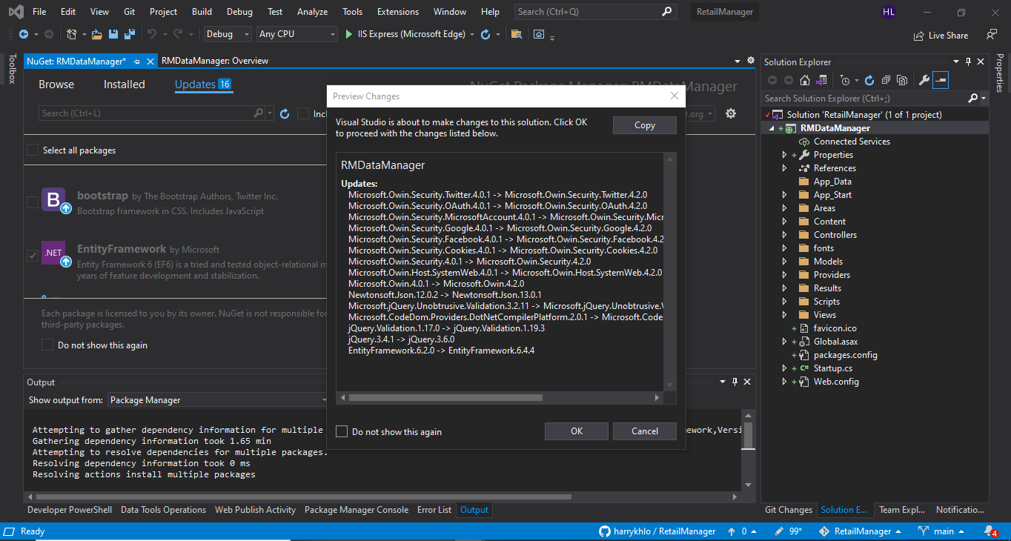

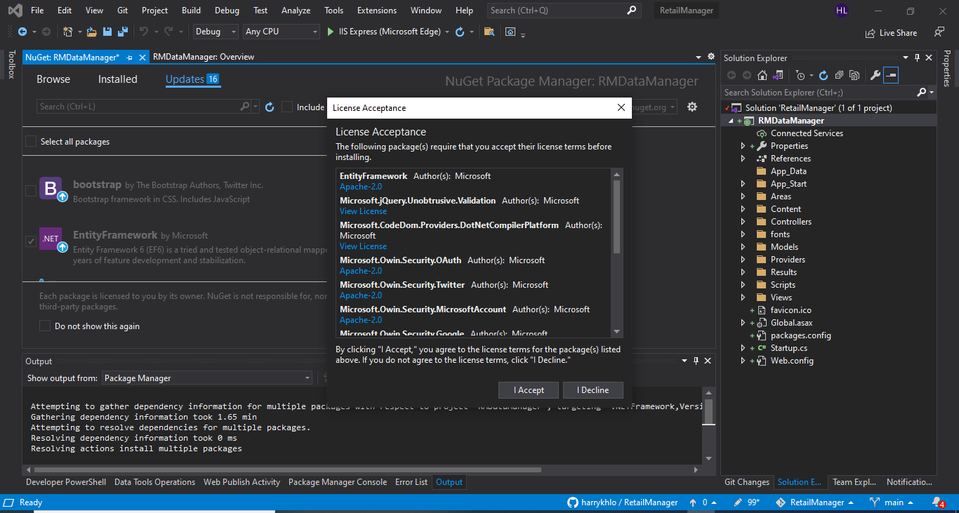

Route for MVC is at RouteConfig.cs

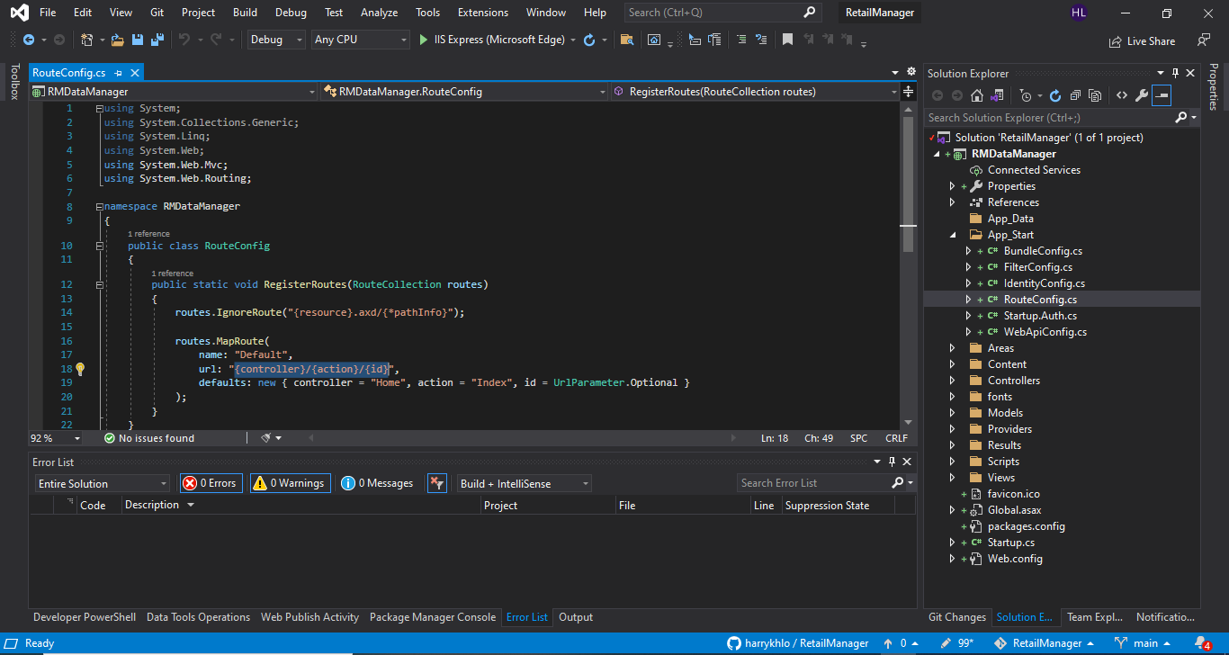

Route for API is at WebApiConfig.cs

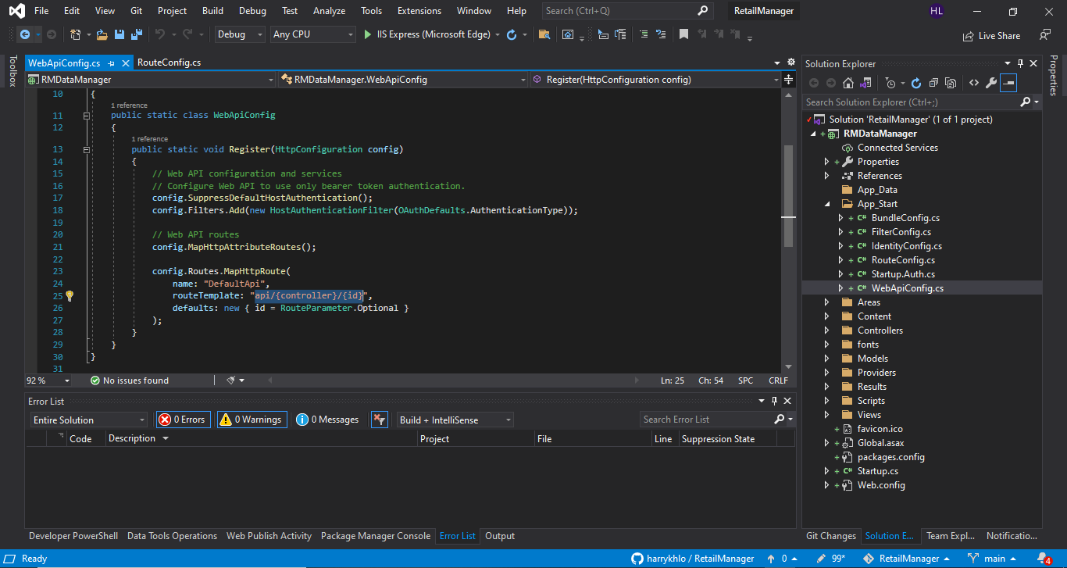

Configuration for user validation e.g. rules for username and password

In IdentiftyConfig.cs

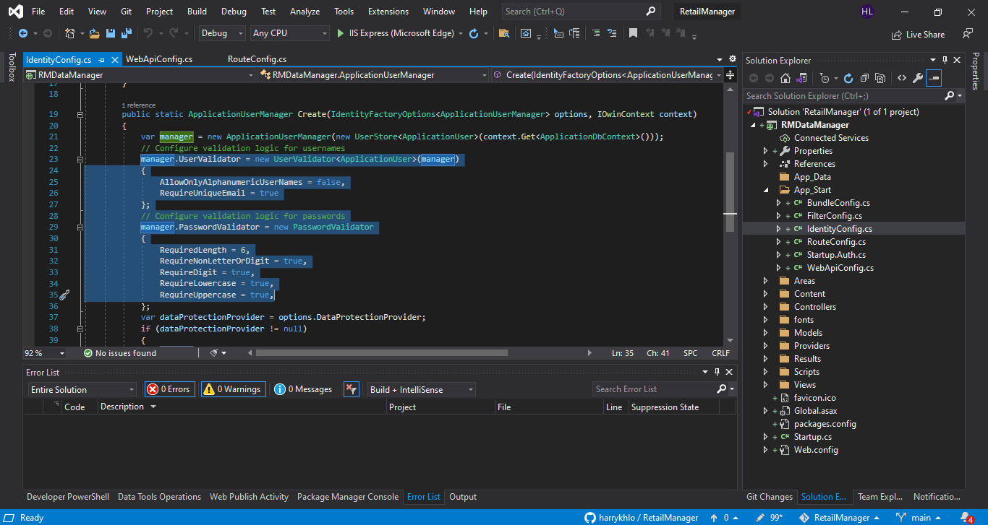

The end point for https://localhost:44375/api/Values is secured by the [Authorize] at the ValuesController.cs below

User who calls this end point has to login

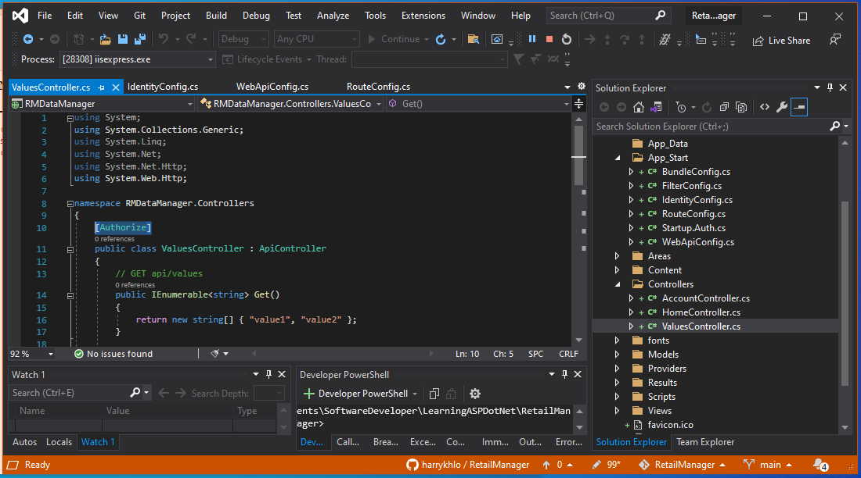

# Run the app and see the API help page

Click run button

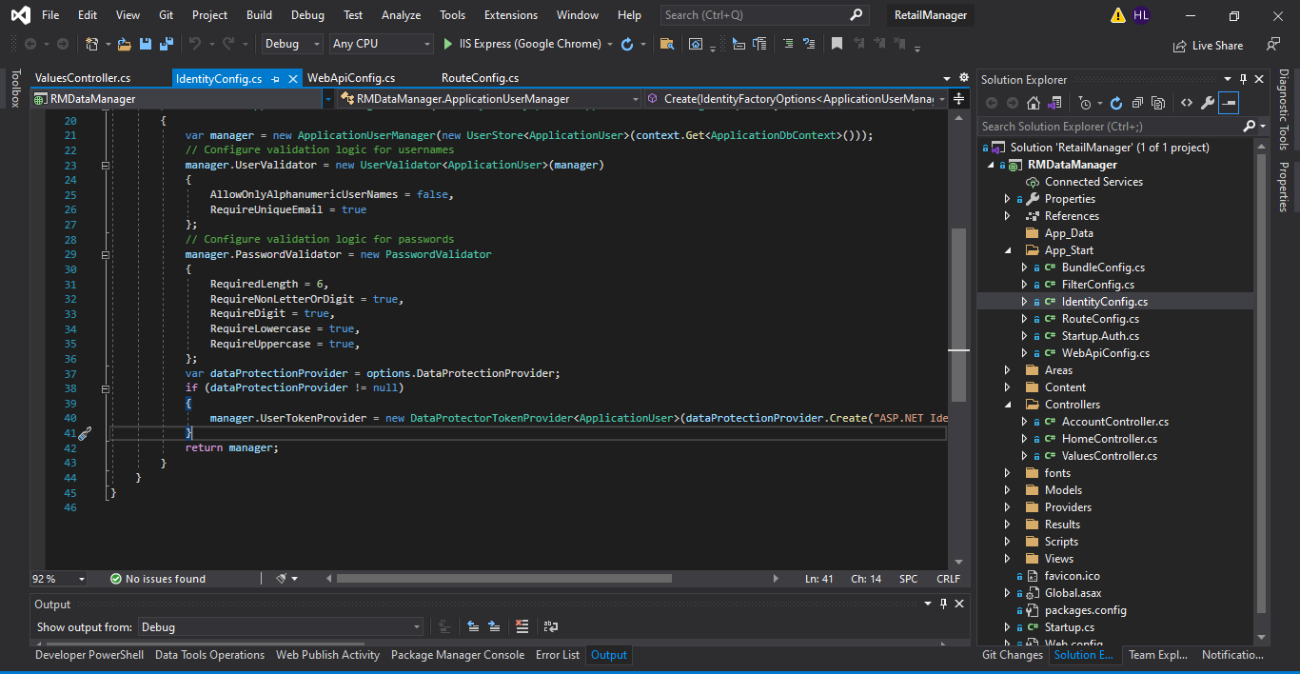

Browser pops up

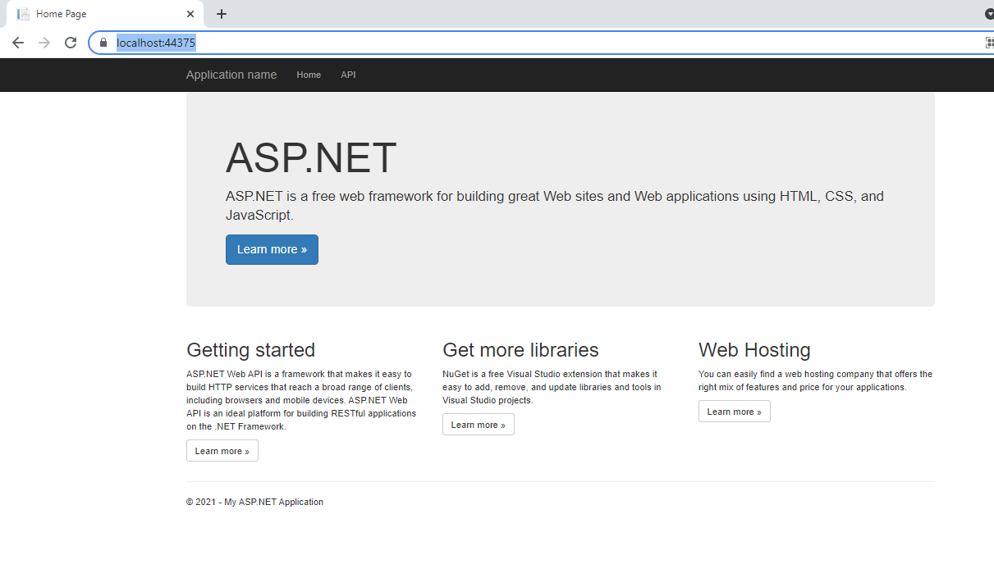

Click API, gives the API help page

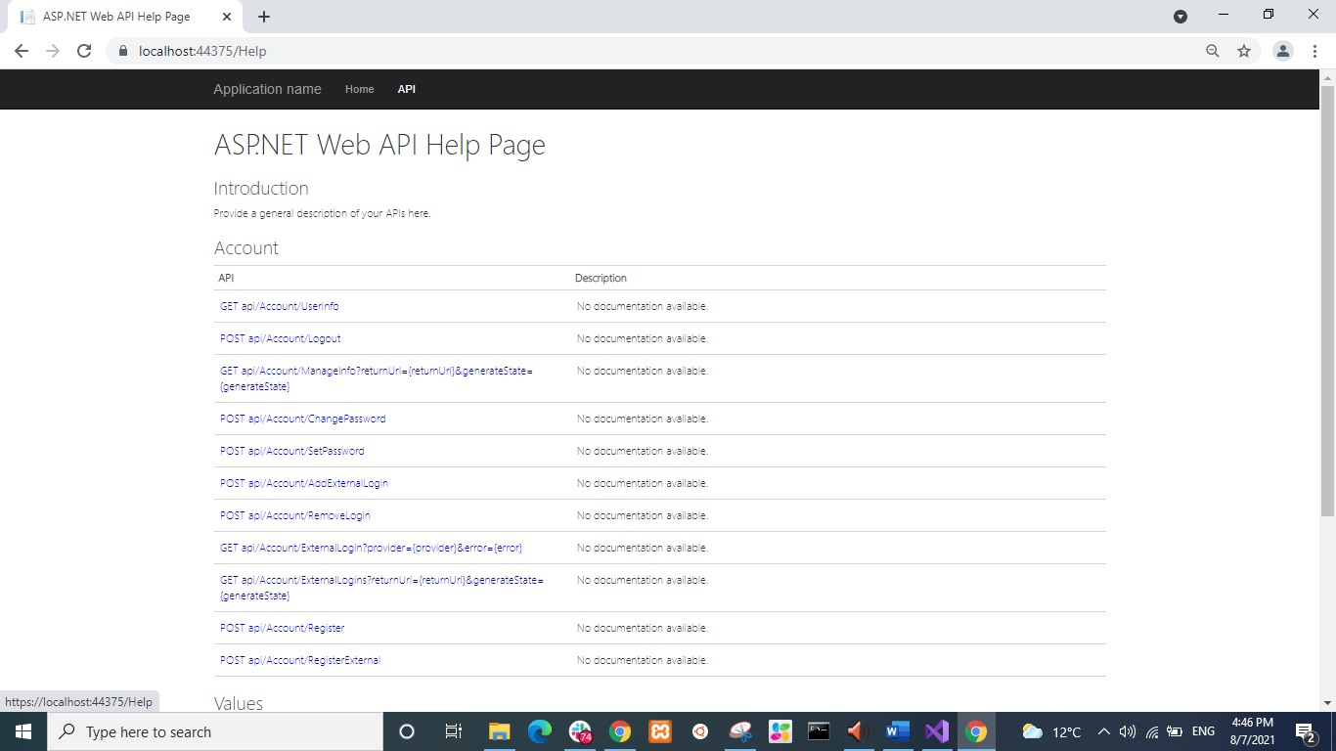

# Register a user with Sample User information

Send post request to the end point for registering a new user

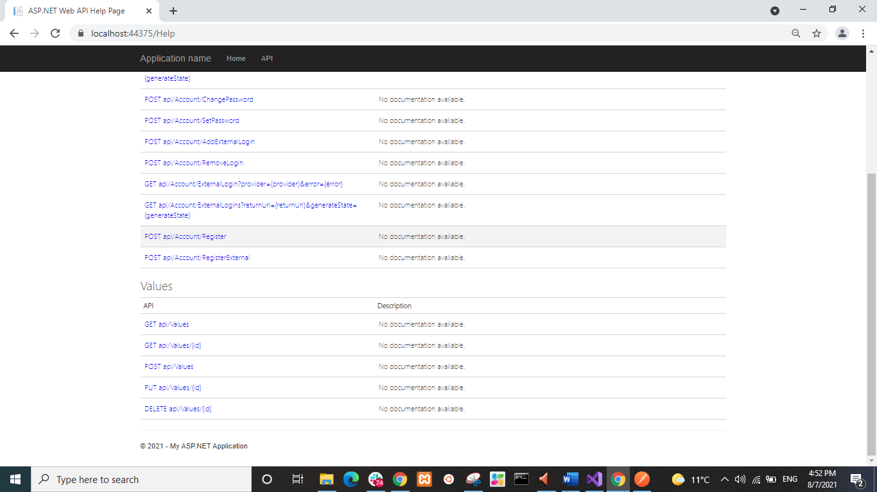

<https://localhost:44375/api/account/register>

The body of the post requests for two users are below:

{

"Email":"email1@email.com",

"Password":"Password1@",

"ConfirmPassword":"Password1@"

}

{

"Email":"email2@email.com",

"Password":"Password1@",

"ConfirmPassword":"Password1@"

}

Sending the post request by using Postman or Advanced REST Client

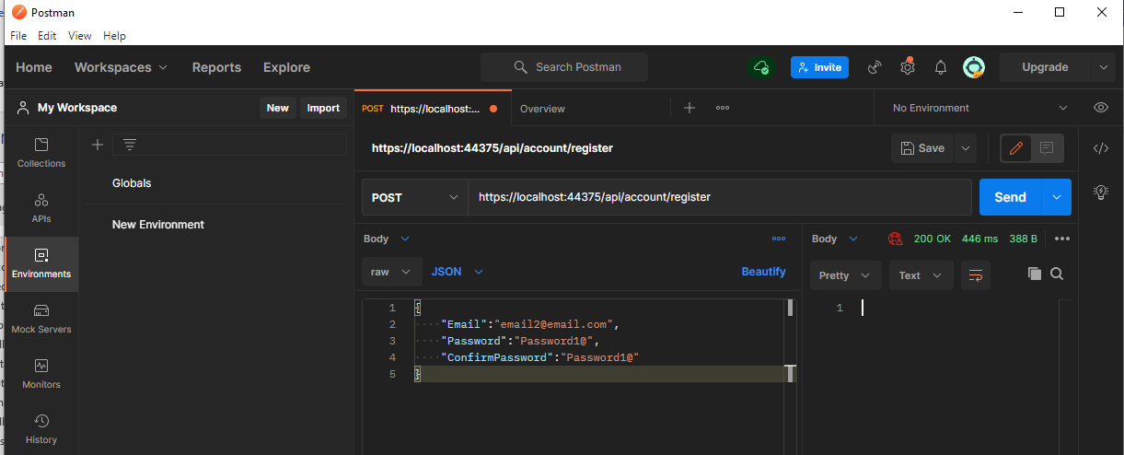

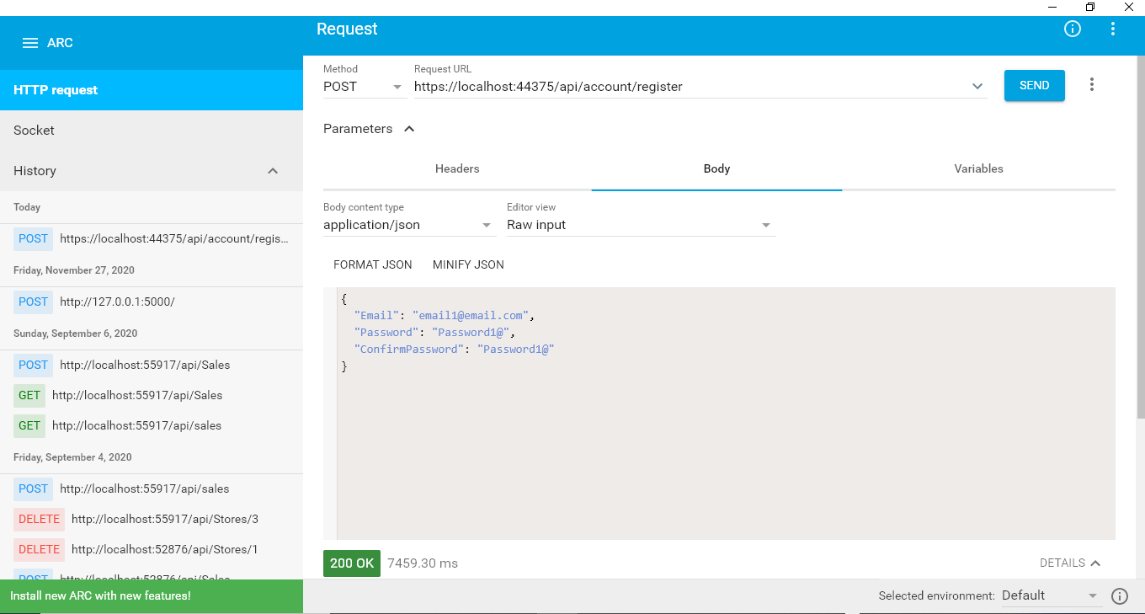

# Get access token

Set a get request to “https://localhost:44375/token” with the grant_type, username and password to the “token” end point as shown below

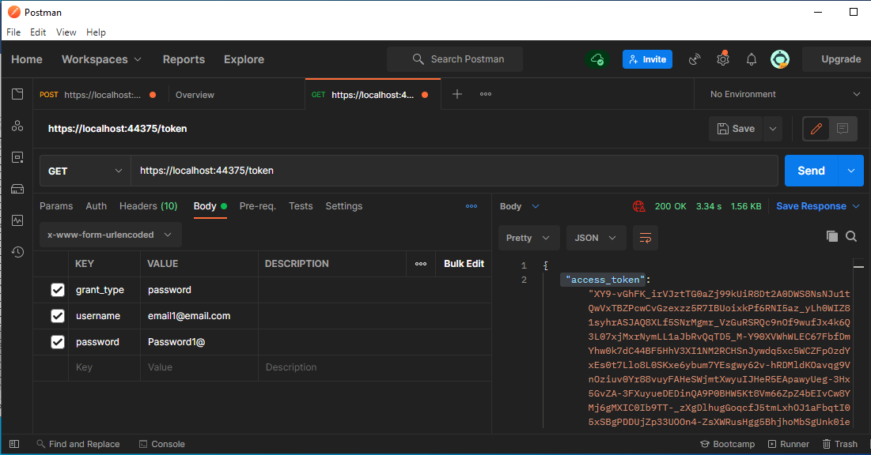

## Question?

How do we know what keys we needed for certain get request e.g. “https://localhost:44375/token”?

# Get values of the user

## Need to get the token see Section 8

get request to “https://localhost:44375/token” with the grant_type, username and password to the “token” end point will get return data as shown below. The access_token is used for get the values of the user.

{

"access_token": "XY9-vGhFK_irVJztTG0aZj99kUiR8Dt2A0DWS8NsNJu1tQwVxTBZPcwCvGzexzz5R7IBUoixkPf6RNI5az_yLh0WIZ81syhrASJAQ8XLf5SNrMgmr_VzGuRSRQc9nOf9wufJx4k6Q3L07xjMxrNymLL1aJbRvQqTD5_M-Y90XVWhWLEC67FbfDmYhw0k7dC44BF5HhV3XI1NM2RCHSnJywdq5xc5WCZFpOzdYxEs0t7Llo8L0SKxe6ybum7YEsgwy62v-hRDMldKOavqg9VnOziuv0Yr88vuyFAHeSWjmtXwyuIJHeR5EApawyUeg-3Hx5GvZA-3FXuyueDEDinQA9P0BHW5Kt8Vm66ZpZ4bEIvCw8YMj6gMXIC0Ib9TT-_zXgDlhugGoqcfJ5tmLxhOJ1aFbqtI05xSBgPDDUjZp33UOOn4-ZsXWRusHgg5BhjhoMbSgUnk0ieoKYMFoTZaER_iSHU-gSToeLpTwumJMsY",

"token_type": "bearer",

"expires_in": 1209599,

"userName": "email1@email.com",

".issued": "Sat, 07 Aug 2021 05:18:53 GMT",

".expires": "Sat, 21 Aug 2021 05:18:53 GMT"

}

## Get values of the user by using the token

End point to: <https://localhost:44375/api/values>

Header key: Authorization

Header Value: Bearer XY9-vGhFK_irVJztTG0aZj99kUiR8Dt2A0DWS8NsNJu1tQwVxTBZPcwCvGzexzz5R7IBUoixkPf6RNI5az_yLh0WIZ81syhrASJAQ8XLf5SNrMgmr_VzGuRSRQc9nOf9wufJx4k6Q3L07xjMxrNymLL1aJbRvQqTD5_M-Y90XVWhWLEC67FbfDmYhw0k7dC44BF5HhV3XI1NM2RCHSnJywdq5xc5WCZFpOzdYxEs0t7Llo8L0SKxe6ybum7YEsgwy62v-hRDMldKOavqg9VnOziuv0Yr88vuyFAHeSWjmtXwyuIJHeR5EApawyUeg-3Hx5GvZA-3FXuyueDEDinQA9P0BHW5Kt8Vm66ZpZ4bEIvCw8YMj6gMXIC0Ib9TT-_zXgDlhugGoqcfJ5tmLxhOJ1aFbqtI05xSBgPDDUjZp33UOOn4-ZsXWRusHgg5BhjhoMbSgUnk0ieoKYMFoTZaER_iSHU-gSToeLpTwumJMsY

(i.e. Header Value is Bearer <<Token>>)

The values for the user with the token are got as below:

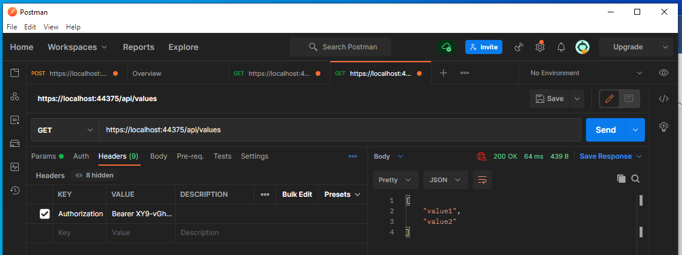

# Location of user data stored

A database is automatically built in the visual studio when the api with the authentication of individual users is created.

The database is shown as below:

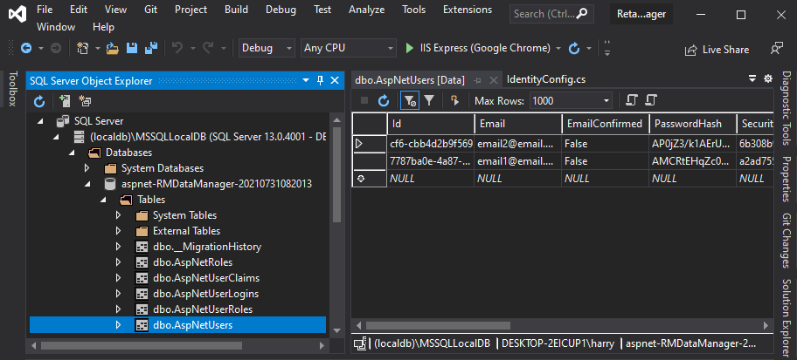

# Add userId obtained from the get request https://localhost:44375/api/values

The get request function is in ValuesController.cs which is inherited from ApiController as shown below

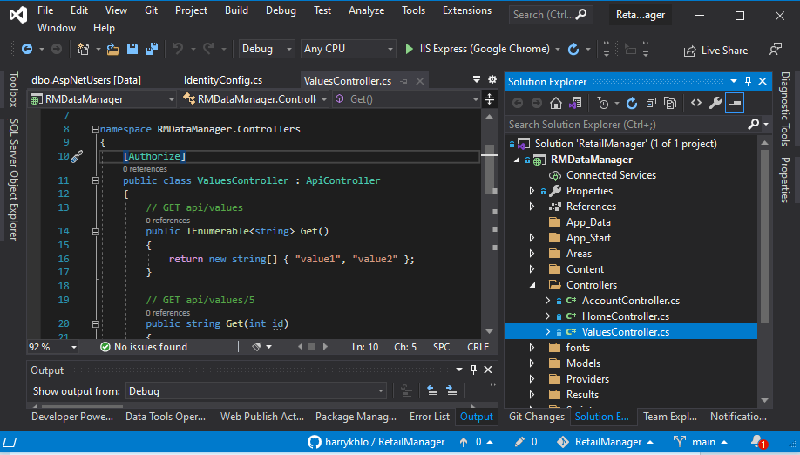

## Add “using Microsoft.AspNet.Identity;”

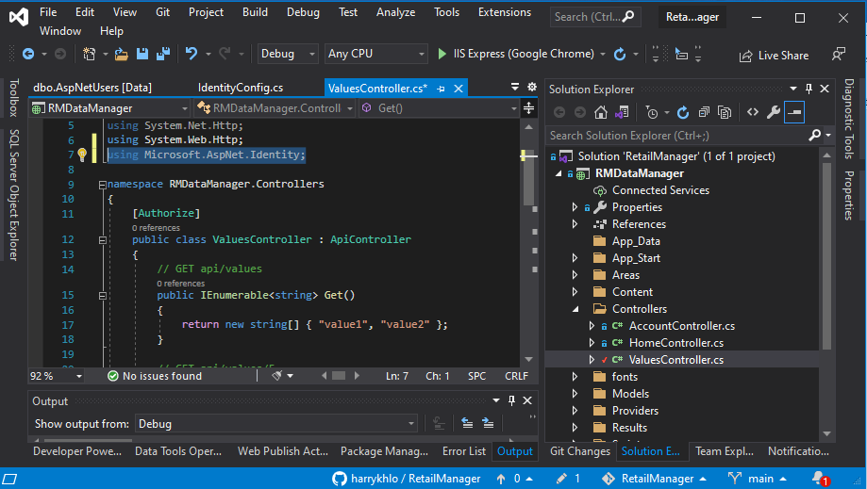

## Get and assign userId in the get function

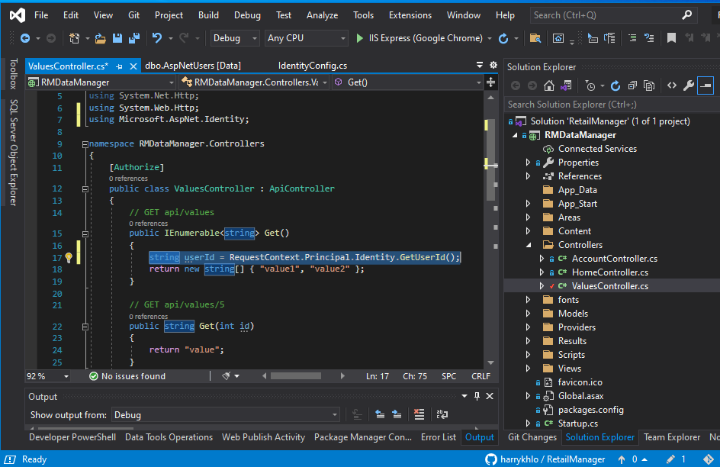

## Return the userId

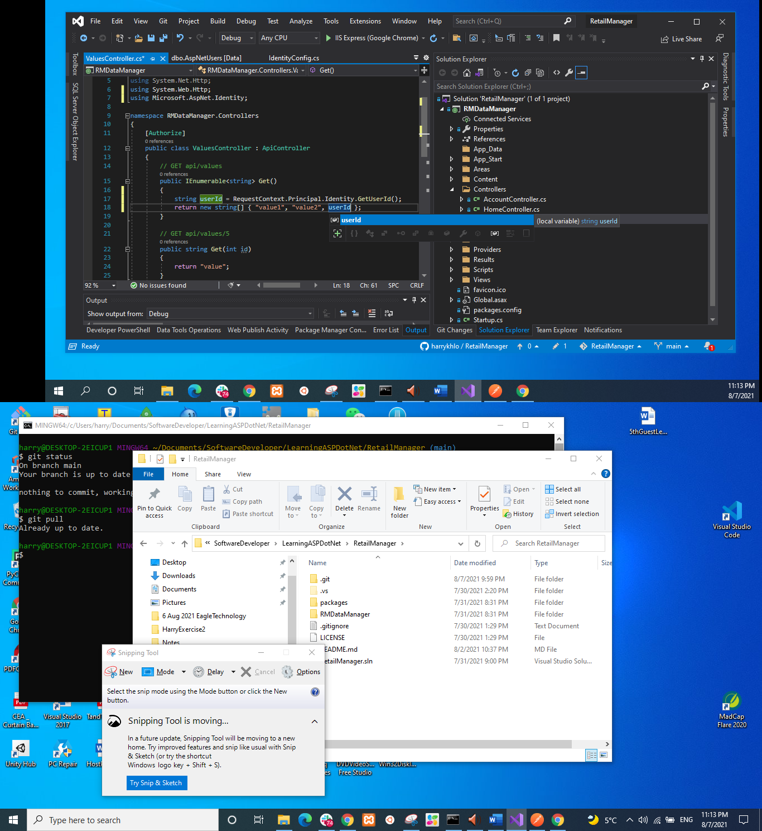

## Tested the end point with Postman returning the userId below

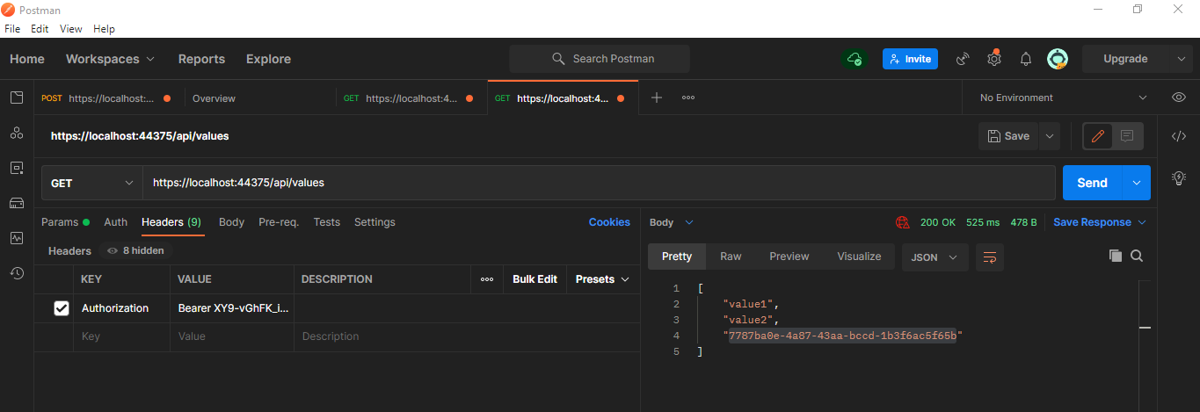

# Difference between API controller and MVC controller

API controller is inherited from ApiController (e.g. ValueController below)

MVC controller is inherited from Controller (e.g. HomeController below)

